**Ongoing Documentation of Work**

During this semester, we conducted research on the Local Garden Management domain and implemented the **Garden Craft** garden management project. Throughout this project, we faced many challenges, but we eventually completed it successfully. Below is a record of our ongoing work throughout the semester.

1. At the beginning of the semester, after finishing our individual assignments and forming a team, we started selecting our domain and topic. Initially, we chose remote education as the topic because both Jiyuan Zhu and I have a background in communication studies. We also considered the travel domain, attempting to create an app that matches like-minded people for trips. However, we ultimately decided to focus on something more relevant to our surroundings. After some in-depth brainstorming, we confirmed our topic as #Local Garden Management.

。

2. After confirming the topic, we immediately began deeper research and brainstorming, thinking about what kinds of features and concepts we should include. With the #Local Garden Management theme already set, we started considering the specific concepts for the project. We came up with many creative ideas, such as a smart irrigation system that adjusts watering frequency based on weather forecasts and plant needs, or a feature where users can upload photos to identify weeds or plant species. However, these ideas were rejected due to technical limitations. Later, by integrating the social and mobile aspects, we finalized our main direction—a smart garden management system.

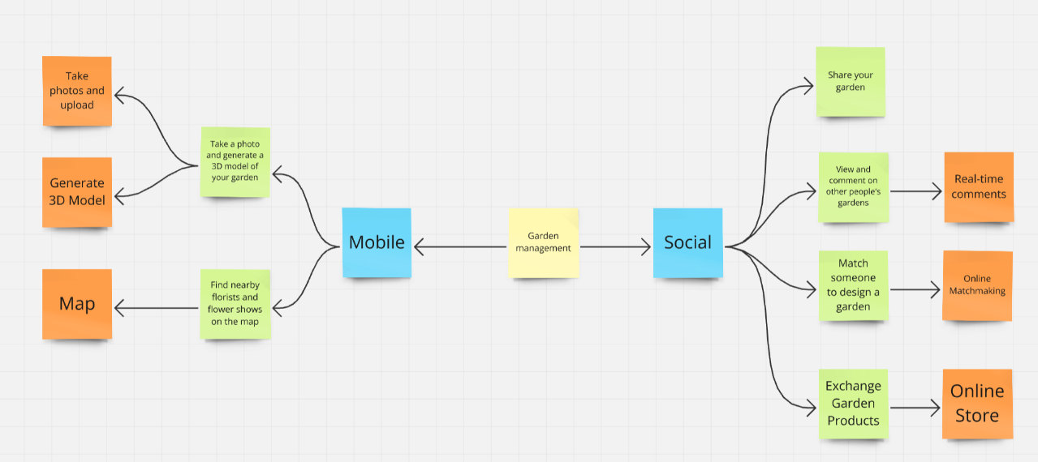

3. After determining the direction, we conducted a series of literature reviews and user research. The literature review provided us with some technical inspiration: it highlighted several key technologies in landscape design, such as virtual reality (VR) for improving design comprehension, GIS and multi-sensor technology for terrain and ecological assessments, and 3D modeling to digitize the design process. Additionally, multi-user VR simulation systems and collaborative applications facilitate team design. We also conducted user research, including interviews, probes, observations, and focus groups. The conclusion we reached is that we need to create a smart garden management app with integrated social features to help users collaborate effectively. Together, the findings from the literature and user research served as the theoretical foundation for our project.

Figure 2 Focus Group

Figure 3 Observation

Figure 1 Literature Review

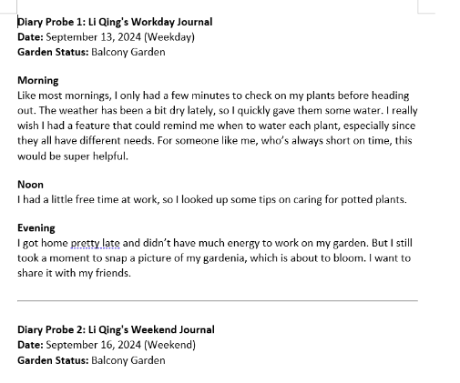

Figure 4 Probe Research

4. After the preliminary research, we established several design concepts: users can upload garden photos and attract comments from others (Social), collaborate with others on garden design and management (Social), use location data to recommend nearby stores selling garden tools (Mobile), generate 3D simulated gardens based on photos (integrating Unity 3D modeling) (Social and Mobile), and create a garden marketplace for exchanging or selling garden products within the community (Social). Based on these concepts, we developed low-fidelity sketches and mid-fidelity prototypes.

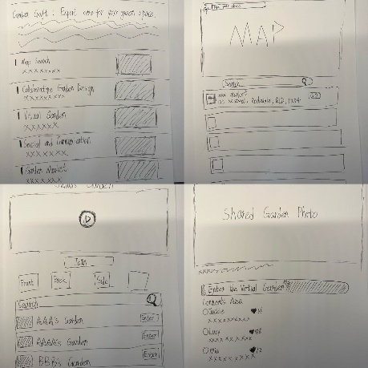

Figure 5 Mid-Fi Prototype

Figure 4 Low-Sketches

5. After completing the foundational preliminary work, we held our first Stand-Up meeting and received valuable feedback from the teaching team:

（1）Consider the factors that make the design effective, meaningful, and practical.

（2）Approach the design from a mobile computing perspective, considering how it relates to specific locations or location awareness.

（3）Focus not only on developing a solution or application but also on its real-world application scenarios.

We decided to implement the following actions in our subsequent work: In the coming period, our team plans to complete the drawing of high-fidelity prototypes, conduct user testing of high-fidelity prototypes, adjust and modify functions, make actual web pages, conduct user testing of web pages, and make final functional adjustments.

6. After the first Stand-Up meeting, we began creating high-fidelity prototypes and developing the final website. Once the high-fidelity prototype was completed, due to time and technical constraints, and following a suggestion from our tutor, we decided to discard the garden marketplace feature as it didn’t strictly belong to the social functionality. We then conducted user testing and feasibility testing using our high-fidelity prototypes.

Our Final Project Link: https://k2222350743-e7923fb80adb.herokuapp.com/garden_page.html

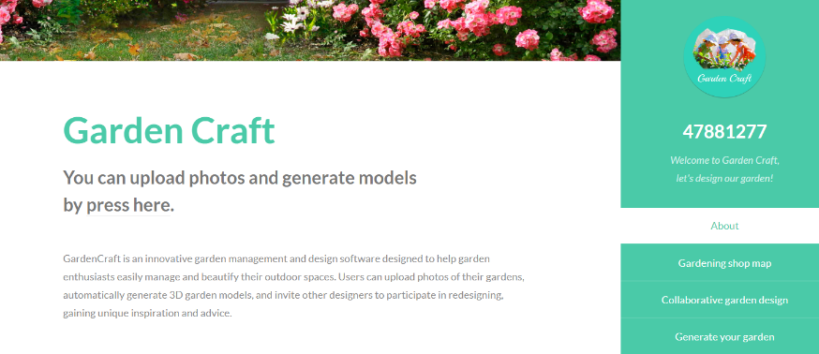

Figure 7 Website Screenshot

Figure 6 High-Fidelity Prototype

7. In the second Stand-Up meeting, the tutor mentioned the following points:

（1）A series of design activities must be completed to pass the assessment, including site observation and each team member conducting at least one interview.

（2）Since the project includes social features, it’s important to consider how to apply social computing concepts and best practices.

（3）More methods to enhance the use of social computing and mobile computing should be considered.

（4）Meeting the requirements of all design activities is a key part of the course.

In the following period of time, we will complete user testing of the web page, supplement all necessary materials, complete the modification and optimization of the web page, and prepare the materials needed for the final trade show. After the web page was officially completed, we conducted another round of user feasibility testing and scenario simulation.

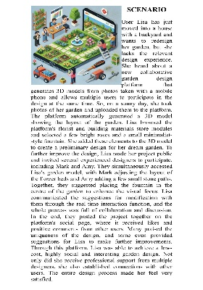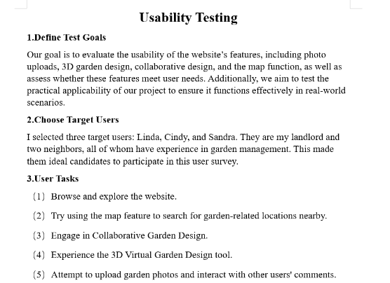

Figure 9 Scenario

Figure 8 Usability Testing

8. By Week 12, we had prepared our poster and promotional materials and began the Trade Show, where we received feedback from both teachers and classmates.